**1) Watch terraform-05 video.**

completed

**2) Execute the script shown in video.**

Create s3 backend  
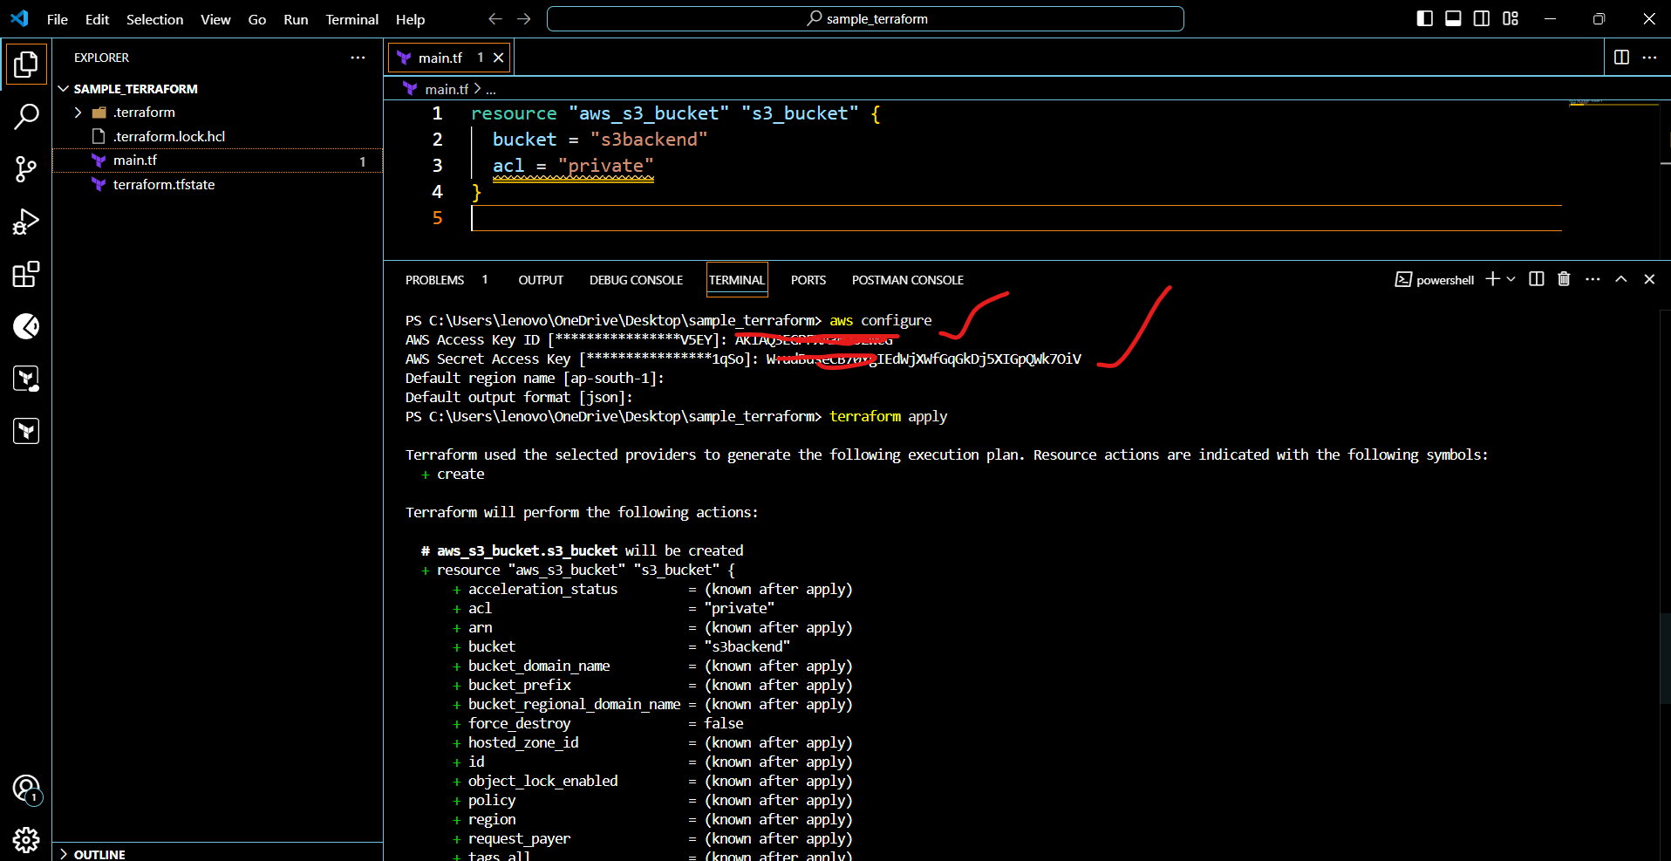

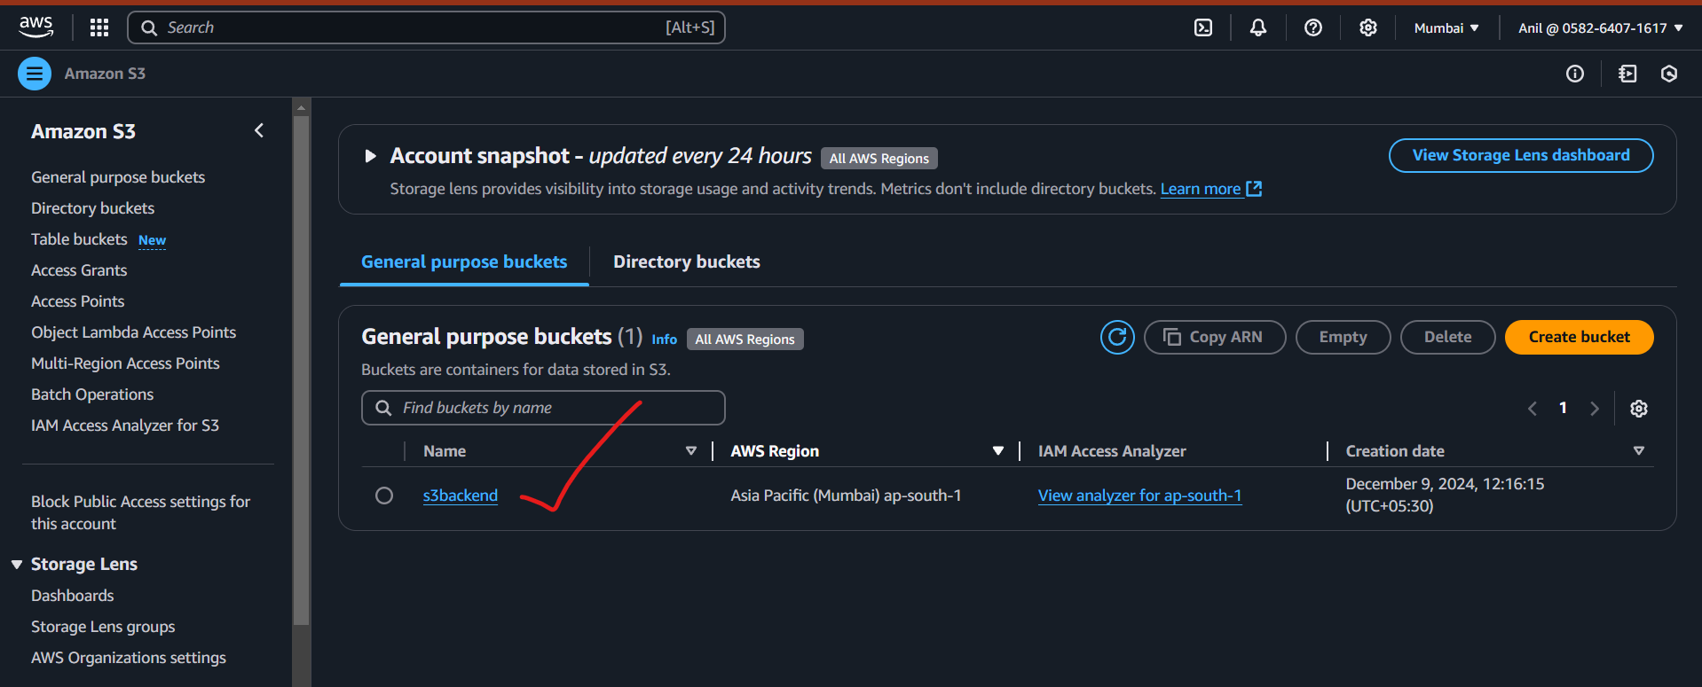

Dynamodb  
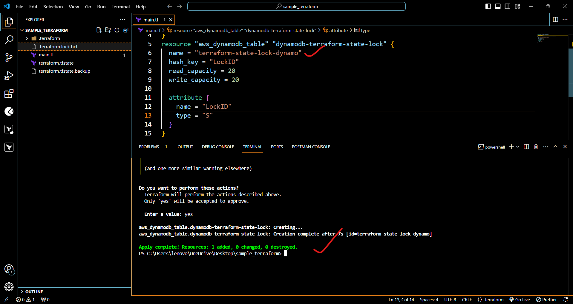

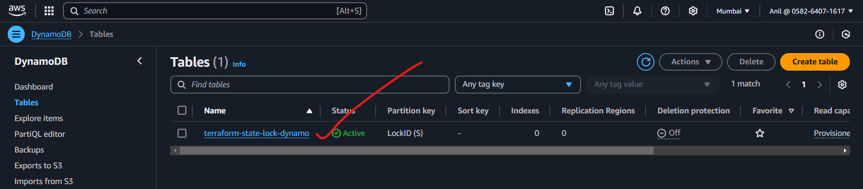

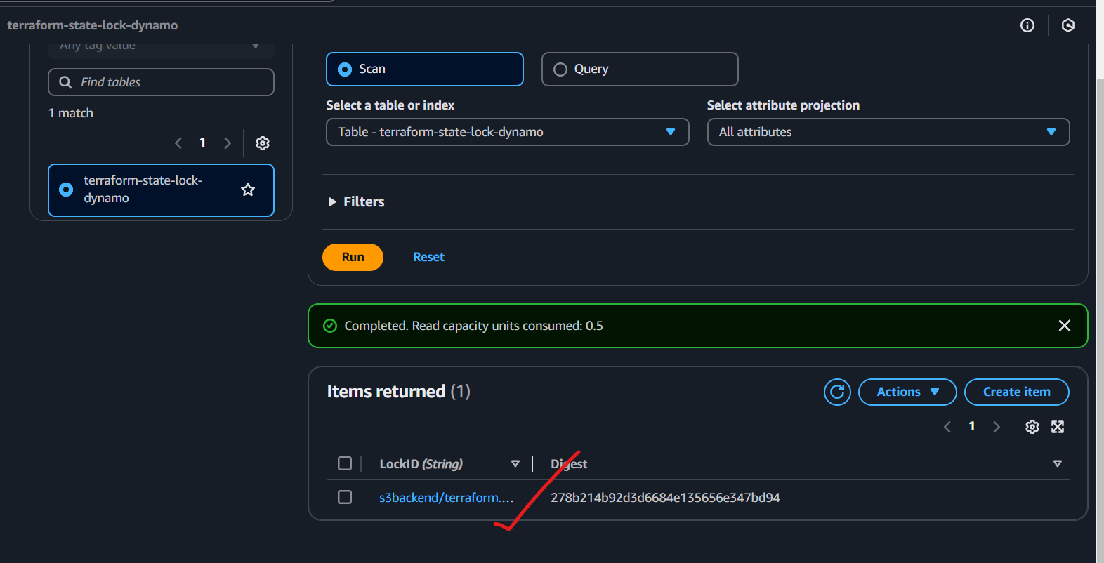

**3) Create one ec2 instance with httpd installed using terraform script.**

provider "aws" {

  region = "ap-south-1" # Replace with your desired AWS region

}

resource "aws_instance" "httpd_instance" {

  ami           = "ami-0614680123427b75e" # Amazon Linux 2 AMI (replace if needed)

  instance_type = "t2.micro"

  # Configure user data to install httpd

  user_data = <<-EOF

              #!/bin/bash

              yum update -y

              yum install -y httpd

              systemctl start httpd

              systemctl enable httpd

              echo "<h1>Welcome to Apache Server on EC2!</h1>" > /var/www/html/index.html

              EOF

  tags = {

    Name = "httpd-instance"

  }

  # Assign a key pair if needed

  key_name = "example" # Replace with your key pair name

  # Add a security group for HTTP access

  vpc_security_group_ids = [aws_security_group.http_access.id]

}

resource "aws_security_group" "http_access" {

  name        = "http-access"

  description = "Allow HTTP access"

  ingress {

    from_port   = 80

    to_port     = 80

    protocol    = "tcp"

    cidr_blocks = ["0.0.0.0/0"] # Allow access from all IPs

  }

  egress {

    from_port   = 0

    to_port     = 0

    protocol    = "-1" # Allow all outbound traffic

    cidr_blocks = ["0.0.0.0/0"]

  }

}

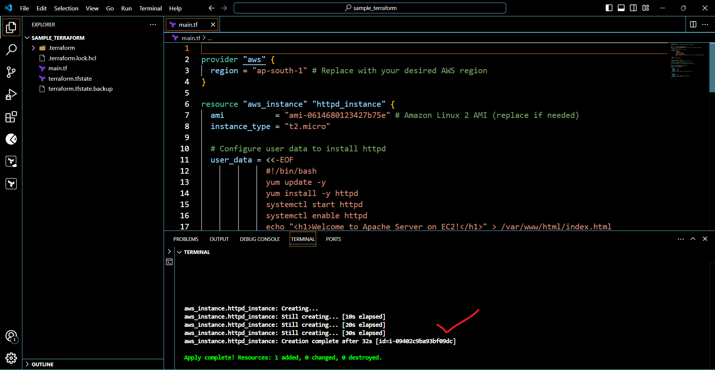

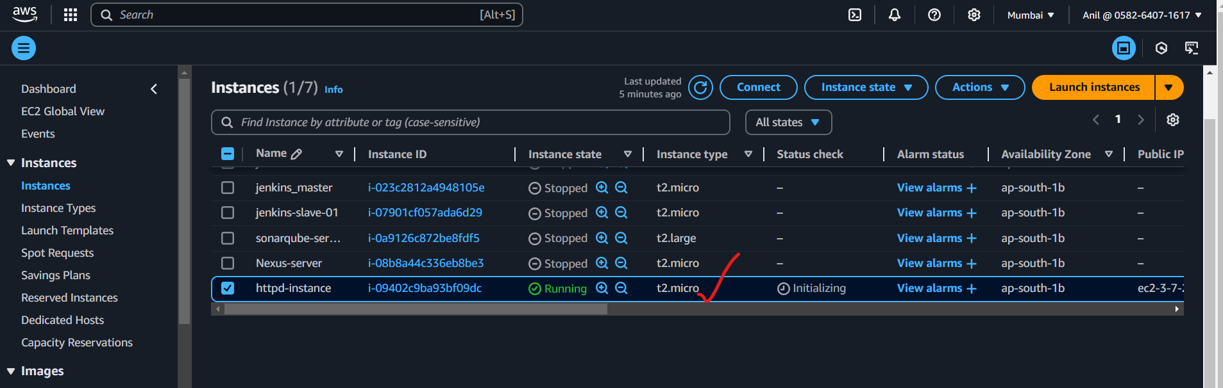

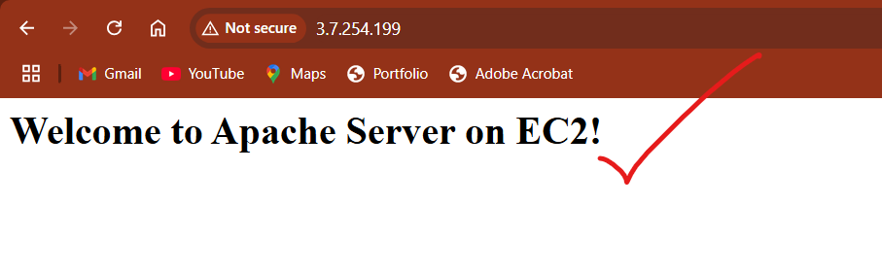

**4) Setup s3 as backend to the task 3.**

terraform {

  backend "s3" {

    bucket         = "s3backend"  /*Replace with your bucket name*/

    key            = "terraform/state.tfstate"

    region         = "ap-south-1"

  }

}

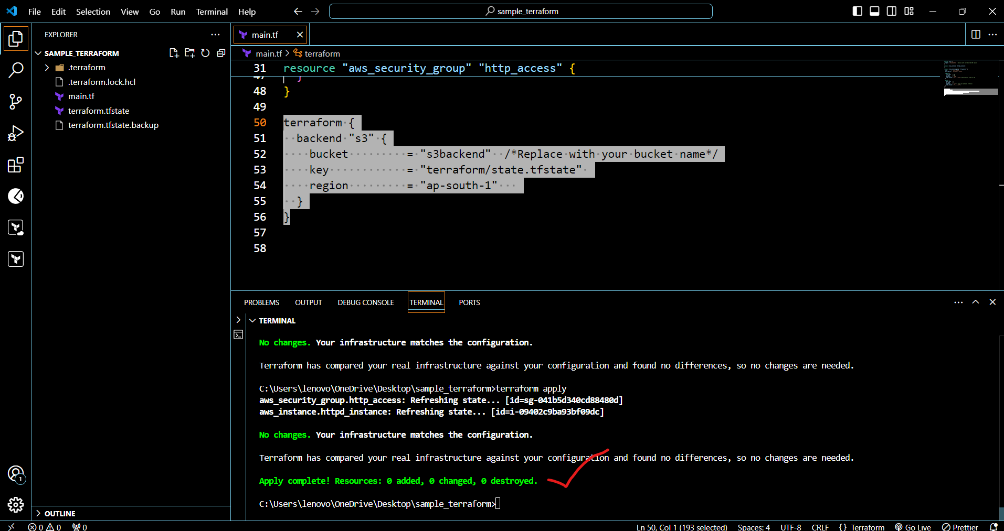

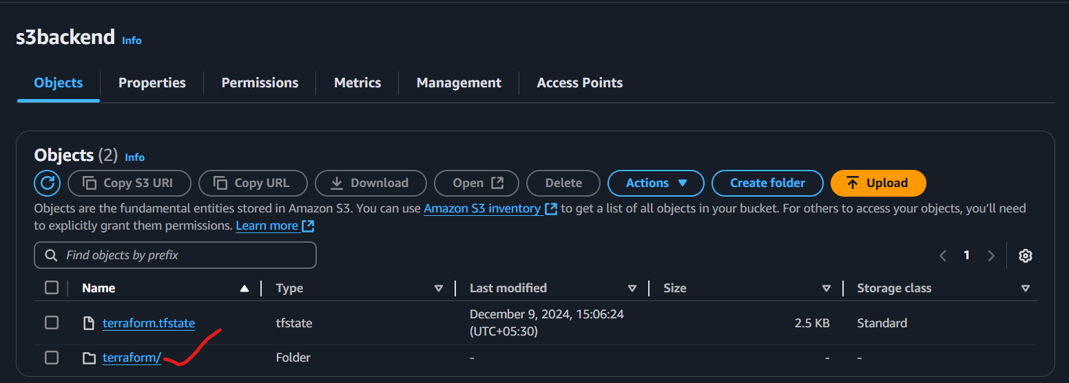

**5) Setup dynamo db locking for task3.**







**6) Watch terraform-06 video.**

completed

**7) Execute the script shown in video.**

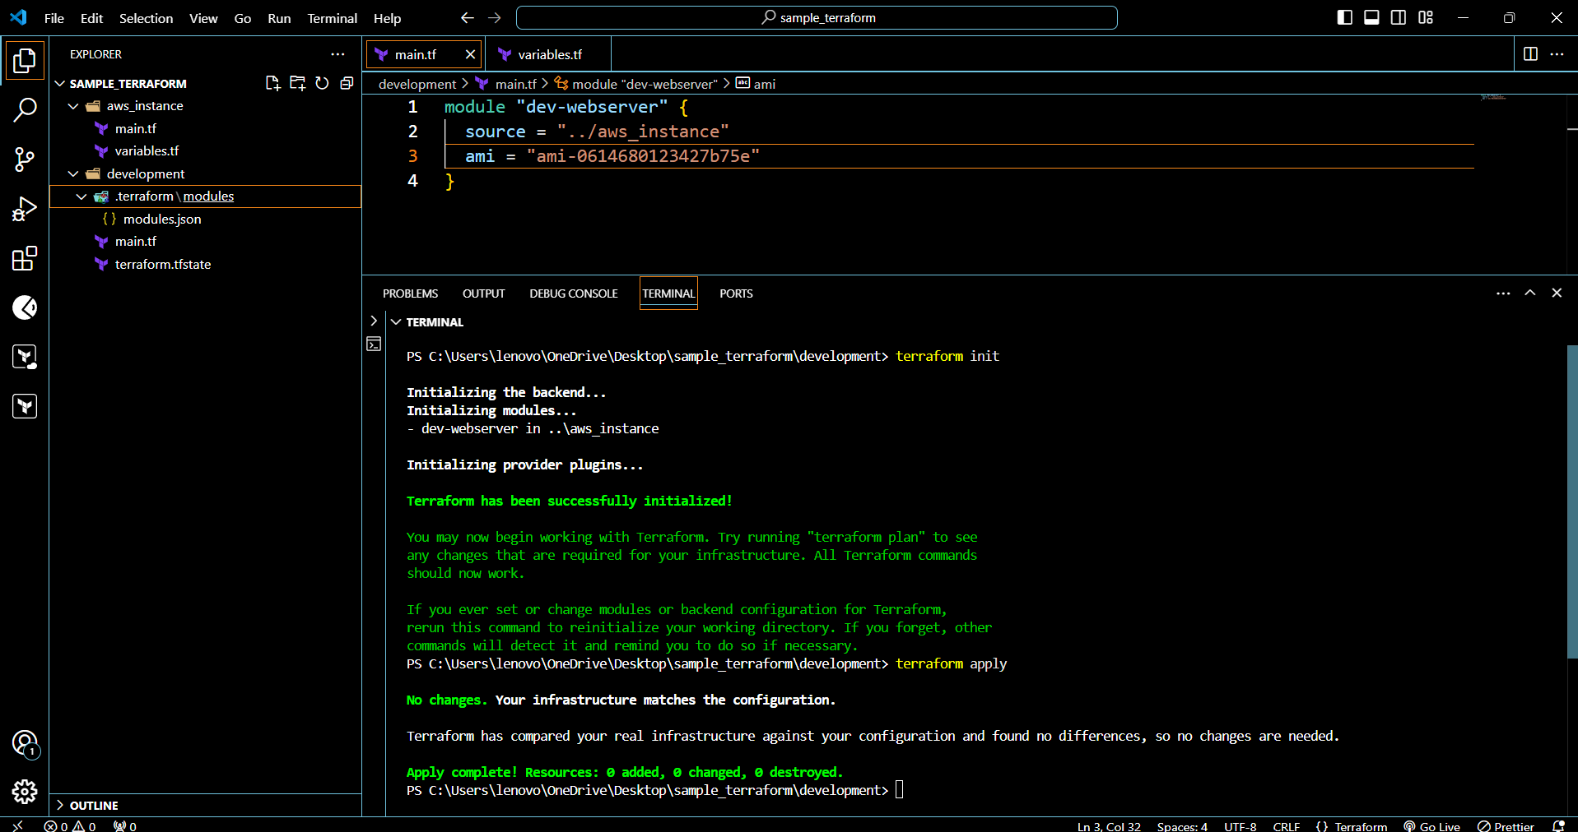

**8) Provision ec2,s3 and vpc using Terraform modules.**

**9) Provision ec2 for 3 different environments (Dev, Staging and Prod) using terraform workspaces.**